Attention Physical Shareholders!!!

Dear Shareholders
SEBI, vide its circular dated November 03, 2021 (subsequently amended by circulars dated December 14, 2021, March 16, 2023 and November 17, 2023) mandated that the security holders (holding securities in physical form), whose folio(s) do not have PAN (Aadhar seeded) or Choice of Nomination or Contact Details or Mobile Number or Bank Account Details or Specimen Signature updated, shall be eligible for any payment including dividend, interest or redemption in respect of such folios, only through electronic mode with effect from April 01, 2024.
Further, relevant FAQs have also been published by SEBI on its website at the following web link for investor awareness: https://www.sebi.gov.in/sebi_data/faqfiles/jan-2024/1704433843359.pdf
In this regard, please note:
- In case of non-updation of PAN (Aadhar seeded) or Choice of Nomination or Contact Details or Mobile Number or Bank Account Details or Specimen Signature in respect of physical folios, dividend/interest etc. shall be paid only through electronic mode with effect from April 01, 2024, upon furnishing all the aforesaid details in entirety.
- If a security holder updates the folio with the KYC details as aforesaid after April 01, 2024, then the security holder would receive all the dividends/ interest etc. declared during that period (from April 01, 2024, till date of updation) automatically in respect of the folio/securities.
In case of any additional information/clarifications, do reach out to our RTA:
Link Intime India Private Limited
Unit: CyberTech Systems and Software Ltd., C101, 247 Embassy Park, 1st Floor, L. B. S. Marg, Vikhroli West, Mumbai - 400 083
or at their designated email: rnt.helpdesk@linkintime.co.in

Please keep the following table:
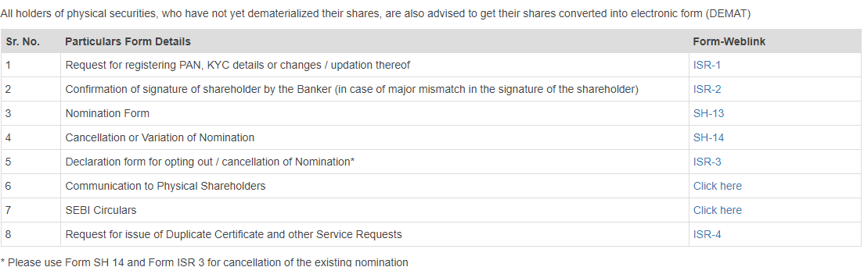
Remove point 7 from the above table
Insert the following table
Relevant SEBI Circulars for ready reference:
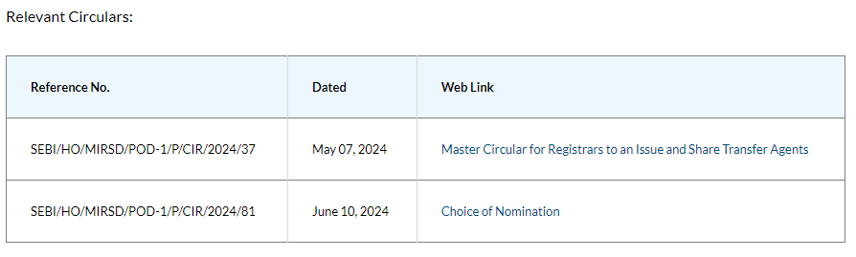
Members holding shares in electronic (DEMAT) form are requested to verify and update immediately any change in their address or bank mandates etc. to their respective Depository Participants with whom they are maintaining their demat accounts.

